ARYAMAN MISHRA

19BCE1027 LAB 1

DR.B.SALEENA

Name=Rohan

Marks=85

Name1=Aryaman

Array=int

Int a[10];

|  |  |  |  |  |  |  |  |  |  |
| --- | --- | --- | --- | --- | --- | --- | --- | --- | --- |
| 4 | 3 | 5 | 6 | 7 | 9 | 10 | 11 | 34 | 12 |

1. 1 2 3 4 5 6 7 8 9

a[10];

#include<stdio.h>

Int main()

{

int a[10];

printf(“Enter the array elements.”);

for(int i=0;i<10;i++)

Scanf(“%d”,&a[i]);

for(int i=0;i<10;i++)

printf(“%d”,a[i]);

}

Int a=5; a

|  |
| --- |
| 5 |

3234x

|  |  |  |  |  |
| --- | --- | --- | --- | --- |
| 4 | 3 | 5 | 1 | 7 |

Bubble sort

34517

34157

31457

.

.

.

13457

X=3

A[i]==x //Searching

A[i]%2==0 //Even Condition

A[i]%2!==0 //odd Condition

1)

#include <stdio.h>

int main()

{

int a[1000],i,n,min,max;

printf("Enter size of the array : ");

scanf("%d",&n);

printf("Enter elements in array : ");

for(i=0; i<n; i++)

{

scanf("%d",&a[i]);

}

min=max=0;

for(i=1; i<n; i++)

{

if(min>a[i])

min=a[i];

if(max<a[i])

max=a[i];

}

printf("minimum of array is : %d",min);

printf("\nmaximum of array is : %d",max);

return 0;

}

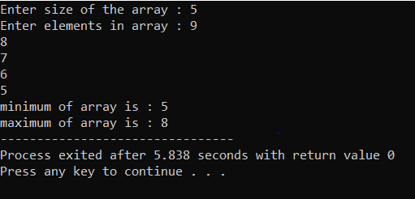

2)

#include <stdio.h>

int main()

{

int a[1000],i,n,j,temp;

printf("Enter size of the array : ");

scanf("%d",&n);

printf("Enter elements in array : ");

for(i=0; i<n; i++)

{

scanf("%d",&a[i]);

}

for(i=0;i<n;i++)

{

for(j=0;j<n-1-i;j++)

{

if(a[j]<a[j+1])

{

temp=a[j];

a[j]=a[j+1];

a[j+1]=temp;

}

}

}

for(int i=0;i<n;i++)

printf("%d",a[i]);

return 0;

}

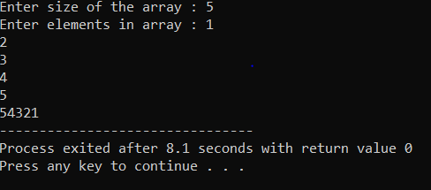

3)

#include

int main()

{

int n;

scanf(“%d”,&n);

int arr[n];

for(int i = 0; i < n; i++)

{

scanf(“%d”,&arr[i]);

}

int count_odd =0, count_even = 0;

for(int i = 0; i < n; i++)

{

if(arr[i] % 2 == 1)

count_odd++;

else

count_even++;

}

printf(“Odd: %d”,count_odd);

printf(“\nEven: %d”,count_even);

return 0;

}

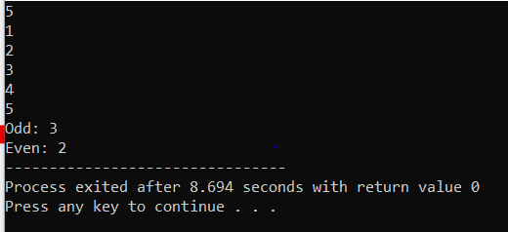

4)

#include <stdio.h>

int main()

{

int arr[1000];

int size, i, toSearch, found;

printf("Enter size of array: ");

scanf("%d", &size);

printf("Enter elements in array: ");

for(i=0; i<size; i++)

{

scanf("%d", &arr[i]);

}

printf("\nEnter element to search: ");

scanf("%d", &toSearch);

found = 0;

for(i=0; i<size; i++)

{

if(arr[i] == toSearch)

{

found = 1;

break;

}

}

if(found == 1)

{

printf("\n%d is found at position %d", toSearch, i + 1);

}

else

{

printf("\n%d is not found in the array", toSearch);

}

return 0;

}

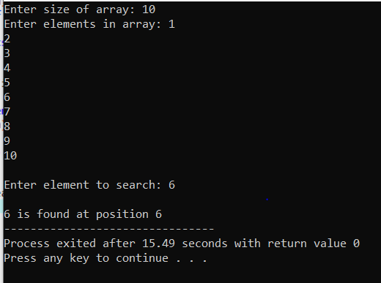

5>#include <stdio.h>

int main()

{

int n;

scanf("%d",&n);

int A[n][n];

int row, col, sum = 0;

printf("Enter elements in matrix \n");

for(row=0; row<n; row++)

{

for(col=0; col<n; col++)

{

scanf("%d", &A[row][col]);

}

}

for(row=0; row<n; row++)

{

sum = 0;

for(col=0; col<n; col++)

{

sum += A[row][col];

}

printf("Sum of elements of Row %d = %d\n", row+1, sum);

}

for(row=0; row<3; row++)

{

sum = 0;

for(col=0; col<n; col++)

{

sum += A[col][row];

}

printf("Sum of elements of Column %d = %d\n", row+1, sum);

}

return 0;

}

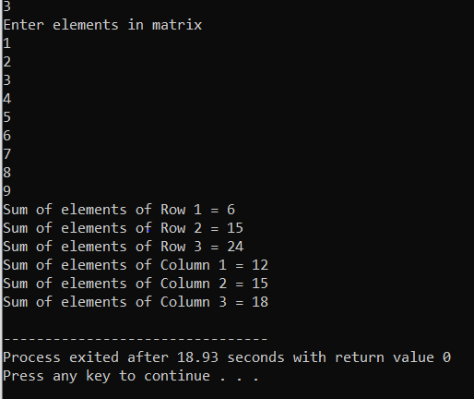

Scenario Programs

1) #include<stdio.h>

int main()

{

int i=0,j=0,temp;

char uni[10][20]={"VIT","SRM","IIT","BIT","KIT","IIIT","BBD","BRDM","PUBG","CMS"};

int rating[10]={20,45,96,62,100,21,77,88,99,85};

char temp_name[20];

char top3[3][20];

char other7[7][20];

for(i=0;i<10;i++)

{

for(j=0;j<10;j++)

{

if (rating[i]>rating[j])

{

temp=rating[i];

rating[i]=rating[j];

rating[j]=temp;

strcpy(temp_name,uni[i]);

strcpy(uni[i],uni[j]);

strcpy(uni[j],temp_name);

}

}

}

printf("Top 3 colleges\n\n");

for(i=0;i<3;i++)

{

strcpy(top3[i],uni[i]);

printf("rating: %d , college_name: %s\n",rating[i],top3[i]);

}

printf("\n\nOther 7 colleges\n\n");

for(i=3;i<10;i++)

{

strcpy(other7[i-3],uni[i]);

printf("rating: %d , college_name: %s\n",rating[i],other7[i-3]);

}

}

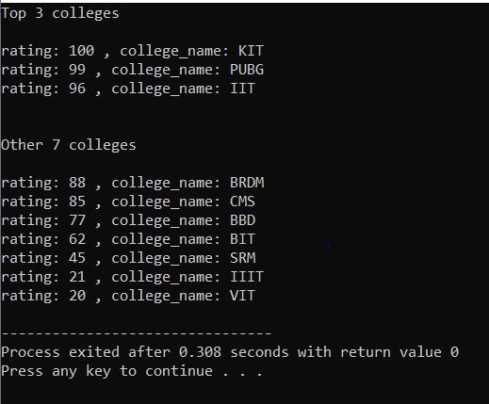

2)

#include<stdio.h>

int main()

{

int c,d;

float difference[10][10],mult[10][10];

float m1[3][2]= {

{42,54},

{36,27},

{34,30}};

float m2[3][2] = {{27,31},

{28,15},

{28,22}};

float m3[1][3]= {{0.75,0.55,1.2}};

for (int c = 0; c < 3; c++)

{

for (int d = 0; d < 2; d++)

{

difference[c][d] = m1[c][d] - m2[c][d];

}

}

for (int i = 0; i < 1; ++i) {

for (int j = 0; j <2 ; ++j) {

mult[i][j] = 0;

}

}

for (int i = 0; i < 1; ++i) {

for (int j = 0; j < 2; ++j) {

for (int k = 0; k < 3; ++k) {

mult[i][j] += m3[i][k] * difference[k][j];

}

}

}

float profit=0.0;

for(int i=0;i<1;i++)

{

for(int j=0;j<2;j++)

{

profit=profit+mult[i][j];

}

}

printf("%f",profit);

}

